**Assignment No. 7**

**Objective:** **Travel Agency System for Booking Ticket and creating customer Account. If customer is new make a account for that customer. Give the discount on holidays or any festival like Diwali, Holi etc. make a guidance for the travel booking System how to book the ticket follow all appropriate procedure. Give all details about that Travel Agency System so it will be easy to customer for booking.**

**Prerequisite:** Html, CSS, JavaScript, AJAX, Database, JQuery, JSP

**Note:** Interested Candidate can also design same in the PHP and Mysql

**Description:**

This application is designed for booking System in Travel agency system, this is very useful for design demo on Travel (Air Line, Railways, Bus) System Online Booking.

**Expected Input:**

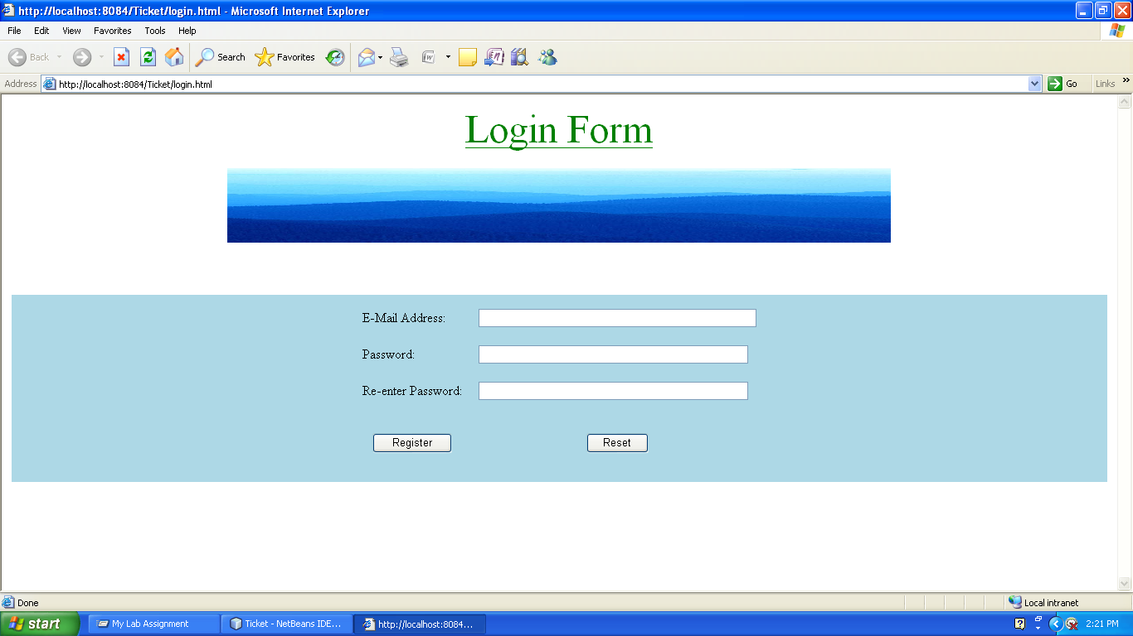**Expected Output**

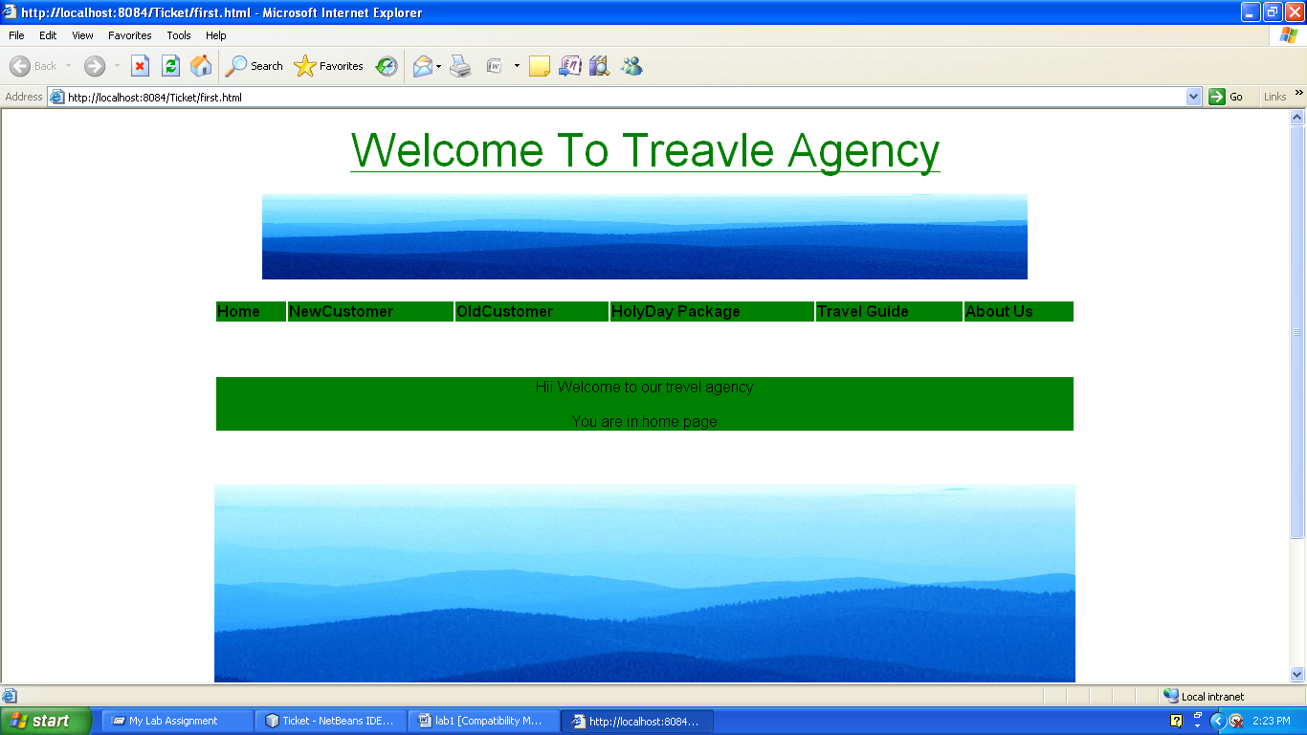

**References:**

1. *Web Technologies- A computer science perspective By Jeffery C. Jackson, Pearson*
2. *Web Technologies-TCP/IP Architecture, and Java Programming By Achyut S. Godbole*
3. *Web Technology-A Developer’s Perspective by N.P Gopalan,J.Akilandeswari,PHI Learning*

**FAQ**

1. What is Http Session in JSP.
2. How to validate data using Session in JSP.
3. What is different between session invalidate() and removeAttribute()
4. How to track any user by using session.